**Challenge Changing Casing in Text**

**toUpperCase( );**

It changes all of the characters in string to upper case version of it.

**toLowerCase( );**

It changes all of the characters in string to lower case version of it.

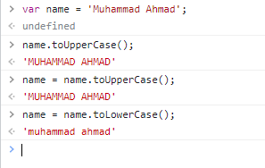

**Note:**

When we run two or more alert commands or any other commands then they run respectively one by one.

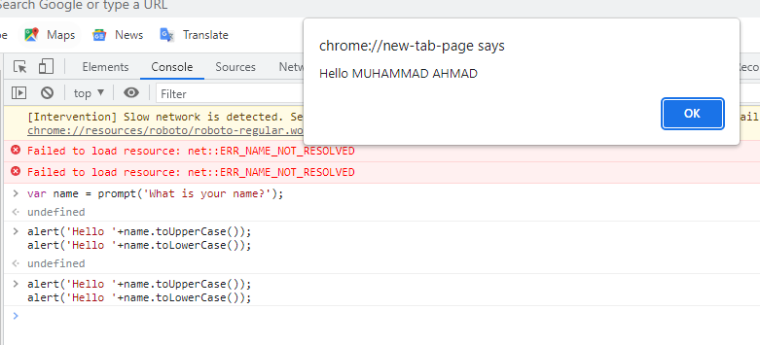

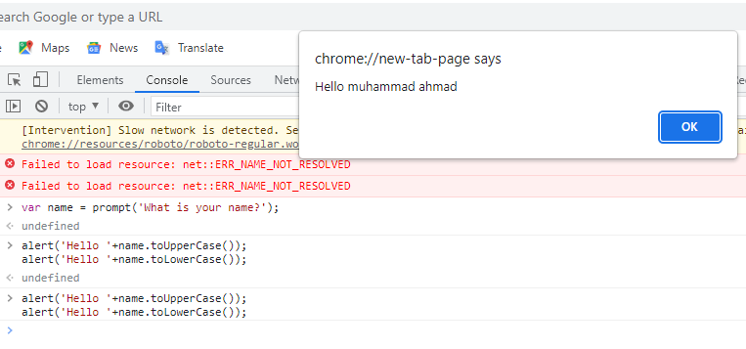

Some other commands are given below in figure.

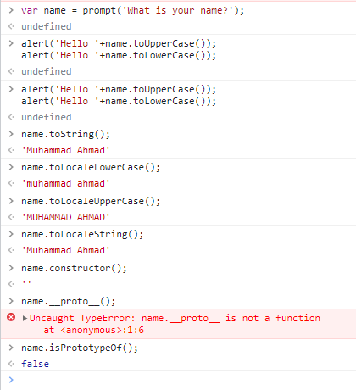

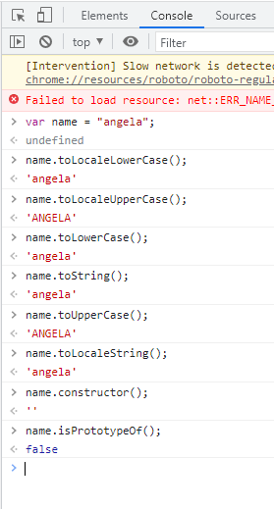

How to capitalize first character and other characters to be in lower case like “**Muhammad Ahmad**”

**Steps:**

1. Create a var that stores a name that user enters via prompt.
2. Capitalize the first letter of their name.
3. isolate the first char
4. turn the first char to upper case
5. isolate the rest of the name
6. change the rest of name to lower case (because name may be as anGELA or angElA etc.)
7. concatenate the first char with the rest of char
8. We use the capitalize version of their name to greet them using an alert.

**Example:**

Create a var that stores a name that user enters via prompt.

var name = prompt("What is your Name?");

//name is angela

//Capitalize the first letter of their name.

//isolate the first char

var firstChar = name.slice(0,1);

firstChar

//turn the first char to upper case

var upperCaseFirstChar = firstChar.toUpperCase();

//isolate the rest of the name

var restOfName = name.slice(1,name.length);

restOfName

//concatenate the first char with the rest of char

var capitalizeName = upperCaseFirstChar + restOfName;

//We use the capitalize version of their name to greet them using an alert.

alert("Hello "+capitalizeName);

capitalizeName

'Angela'

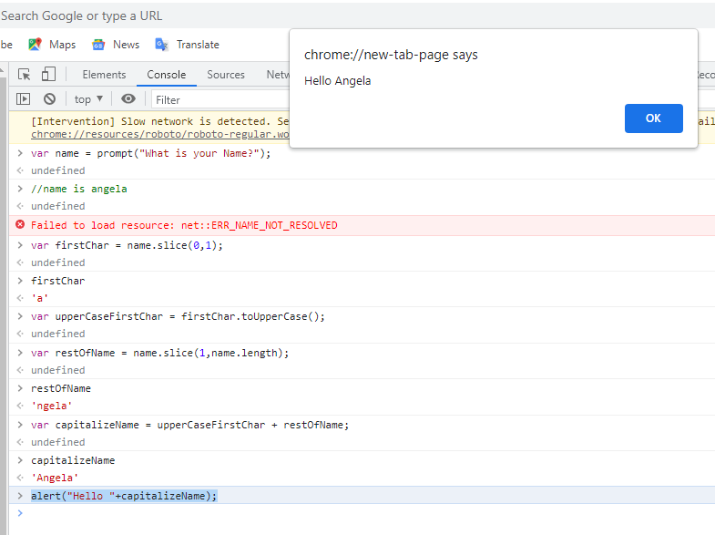

var name = prompt('What is your name?');

name

'muhammad ahmad'

var firstChar = name.slice(0,1);

firstChar

'm'

var secondChar = name.slice(12,13);

secondChar

'a'

var firstCharUpperCase = firstChar.toUpperCase();

firstCharUpperCase

'M'

var secondCharUpperCase = secondChar.toUpperCase();

secondCharUpperCase

'A'

var restOfFirstName = name.slice(1,8);

restOfFirstName

'uhammad'

var restOfSecondName = name.slice(10,15);

restOfSecondName

'hmad'

var capitalizeName = firstCharUpperCase+ restOfFirstName+' '+ secondCharUpperCase+restOfSecondName;

capitalizeName

'Muhammad Ahmad'

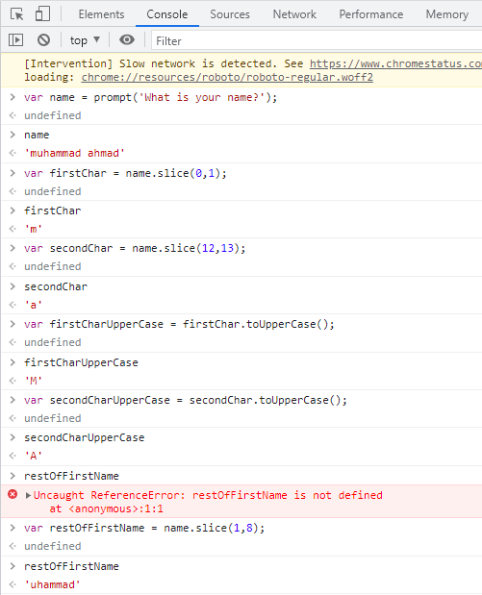

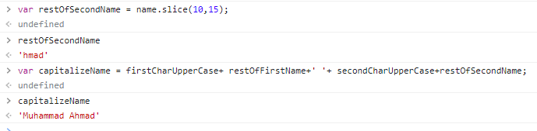

**Method 2:**

Second method is take name from user as first name and last name then convert them into first char upper case and other in lower case then combine first name and last name using string concatenation.